M.MOHANA

231901031

**Week-4: Sample Digital Program**

**1.**

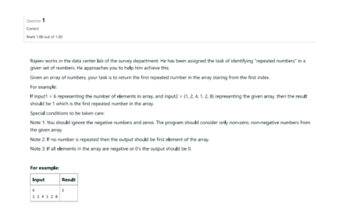import java.util.Scanner; class Repeat{ public

static void main(String[] args){

Scanner s=new Scanner(System.in);

System.out.println("Enter number of elements in array:");

int size=s.nextInt(); int[]

array = new int[size];

System.out.println("Enter " + size + " elements:");

for (int i = 0; i < size; i++) {

array[i] = s.nextInt();

}

boolean foundRepeat = false;

for (int i = 0; i < size; i++) { for

(int j = i + 1; j < size; j++) {

if (array[i] == array[j]) {

System.out.println("First repeated number: " + array[i]);

foundRepeat = true;

break;

CSE(CYBER SECURITY)

}

}

if (foundRepeat) {

break;

}

}

if (!foundRepeat) {

System.out.println("No repeated numbers found.");

}

s.close();

}

}

**Output:**

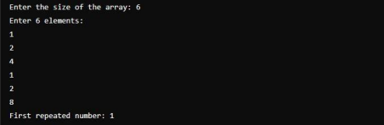 **2.**

CSE(CYBER SECURITY)

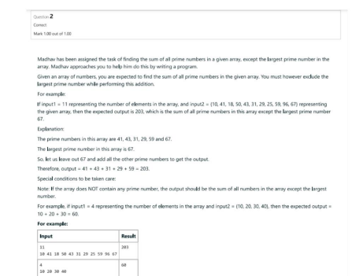

**Program:**

import java.util.Scanner;

public class PrimeSumExcludingLargest { public static void main(String[] args) { Scanner scanner = new Scanner(System.in); System.out.print("Enter the size of the array: "); int size = scanner.nextInt(); int[] array = new int[size]; int largestPrime = 0, primeSum = 0, largestElement = Integer.MIN_VALUE;

System.out.println("Enter " + size + " elements:");

for (int i = 0; i < size; i++) {

array[i] = scanner.nextInt(); if

(isPrime(array[i])) {

primeSum += array[i]; if

(array[i] > largestPrime) {

largestPrime = array[i];

}

}

if (array[i] > largestElement) {

largestElement = array[i];

}

}

CSE(CYBER SECURITY)

if (primeSum == 0) {

primeSum = sumArray(array) - largestElement;

System.out.println("No prime numbers found. Sum excluding the largest element: " + primeSum);

} else {

primeSum -= largestPrime;

System.out.println("Sum of primes excluding the largest prime: " + primeSum); }

scanner.close();

}

public static boolean isPrime(int num) {

if (num <= 1) return false;

for (int i = 2; i * i <= num; i++) {

if (num % i == 0) return false;

}

return true;

}

public static int sumArray(int[] array) {

int sum = 0; for

(int num : array) {

sum += num;

}

return sum;

}

}

**Output:**

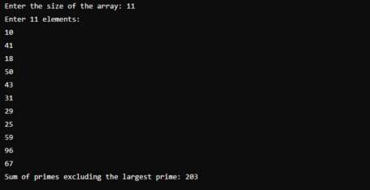

CSE(CYBER SECURITY)

**3.**

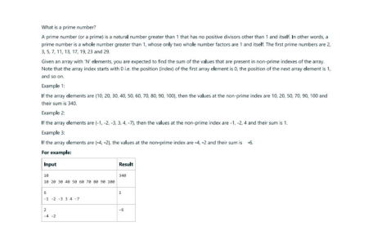**Program:**

import java.util.Scanner;

public class SumNonPrimeIndexes { public static

void main(String[] args) { Scanner scanner =

new Scanner(System.in);

System.out.print("Enter the size of the array: ");

int size = scanner.nextInt();

int[] array = new int[size];

System.out.println("Enter " + size + " elements:");

for (int i = 0; i < size; i++) {

array[i] = scanner.nextInt();

}

int sum = 0; for (int i =

0; i < size; i++) {

if (!isPrime(i)) {

sum += array[i];

}

}

System.out.println("Sum of values at non-prime indexes: " + sum); scanner.close();

}

CSE(CYBER SECURITY)

public static boolean isPrime(int num) {

if (num <= 1) return false;

for (int i = 2; i * i <= num; i++) {

if (num % i == 0) return false;

}

return true;

}

}

**Output:**

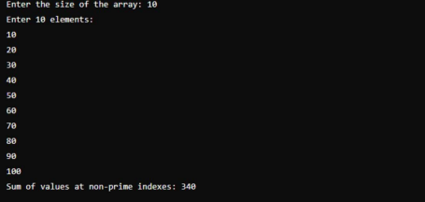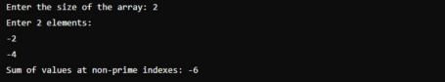

CSE(CYBER SECURITY)